
COMP30261- Distributed DataBase Engineering
Technical Report
Name: Vasu Goyal
Course: BSC Computer Science (AI)
Student Number: N1202625

Contents
Introduction 3
Problem Statement: 3
Key features: 3
Literature Review 4
Java installation 4
Hadoop installation 4
Configuration files 5
Firewall Configuration for Multi-Node Hadoop Operation 7
SSH Setup and Passwordless Authentication 7
Preparing the Five-Node Cluster Environment 7
Formatting the NameNode 8
Starting the Hadoop Cluster and Verifying Daemons 8
HDFS Data Storage Setup and Distribution 9
Developing the MapReduce Program 9
Running the MapReduce Job 10
Viewing Results from Terminal and Web Interfaces 10
Critique, Discussion, and Summary 11
Evaluation of the Solution: Effectiveness and Efficiency 11
What Worked Well 12
What Did Not Work Well 12
Insights Gained 12
Future Enhancements and Development 12
Summary 12
Appendix………………………………………………………………………………………………………..13
Bibliography……………………………………………………………………………………………………14
References……………………………………………………………………………………………………..15

Introduction

Problem Statement: The objective of this laboratory project is to investigate the distribution of road-traffic casualties in the 2018 UK Road Safety dataset by utilising the Hadoop distributed computing environment. The task requires identifying and counting the number of Accident Index entries associated with each defined Casualty Severity category. To perform this analysis at scale, a multi-node Hadoop cluster is built and configured, providing distributed storage via HDFS and parallel execution through YARN and the MapReduce programming model. A custom Java MapReduce job is implemented to extract severity attributes and compute aggregated counts, demonstrating the practical application of distributed data-processing techniques for real-world analytical workloads.

Key features: The Hadoop environment used for this coursework was deployed on a fully-distributed, multi-node cluster consisting of five ubuntu linux virtual machines running on VMware Workstation. The system exceeds the minimum requirement of a three-node setup by implementing a complete production-style architecture, consisting of one primary master node and four worker nodes. The master node (machine01) is configured to run the NameNode and YARN ResourceManager services, and it also participates in storage and computation through its DataNode and NodeManager roles. The second node (machine02) hosts the SecondaryNameNode for HDFS checkpointing and additionally operates as a worker node by running both a DataNode and NodeManager. The remaining machines (machine03–machine05) function as dedicated worker nodes, each configured with DataNode and NodeManager services to support distributed storage and parallel processing. The nodes were configured with consistent Java versions, synchronised environment variables, shared Hadoop installations, and passwordless SSH to enable seamless communication across the cluster.
HDFS was configured with replicated storage, ensuring that data is distributed across multiple DataNodes to provide fault tolerance and high availability. Core configuration files—core-site.xml, hdfs-site.xml, yarn-site.xml, and mapred-site.xml—were customised to define the default filesystem, replication factors, data directories, and YARN execution settings. This environment mirrors real-world big data infrastructure by enabling distributed storage, parallel execution, and automatic resource scheduling.
In addition to the required Hadoop services, the cluster includes extended capabilities that go beyond the coursework specification. A fully functioning Apache Spark installation was added to all nodes, enabling in-memory distributed processing for future large-scale analytics tasks. Web-based management interfaces, including the NameNode UI (port 9870) and ResourceManager UI (port 8088), were enabled to monitor cluster health, data distribution, and the execution lifecycle of MapReduce jobs. The system also supports YARN container logs, block-level HDFS inspection, and multi-node file distribution, offering deeper insight into how large datasets are processed across distributed systems.
Overall, the installation not only satisfies the technical requirements of the coursework but also introduces advanced features such as full YARN-based scheduling, multi-node Spark support, enhanced monitoring tools, and a production-style distributed architecture. These additions provide a richer learning environment and demonstrate an understanding of real-world big data deployments beyond the basic laboratory setup.

Literature Review: The adoption of distributed data platforms has grown rapidly as organisations face increasingly large and complex datasets. Hadoop remains a foundational technology in this space, combining HDFS for fault-tolerant distributed storage with the MapReduce model for scalable batch analytics (Shvachko et al., 2010). Modern deployments commonly integrate YARN to support multiple execution engines and flexible resource scheduling (Vavilapalli et al., 2013). Although newer frameworks like Apache Spark offer faster in-memory computation, MapReduce continues to play a significant role in large-scale ETL, log processing, and regulatory workloads due to its stability and predictable performance (Zaharia et al., 2016). By building a full multi-node Hadoop cluster and extending it with Spark, this project mirrors current industry practices and demonstrates how distributed systems are used to analyse real datasets such as the 2018 Road Safety records.

Java installation
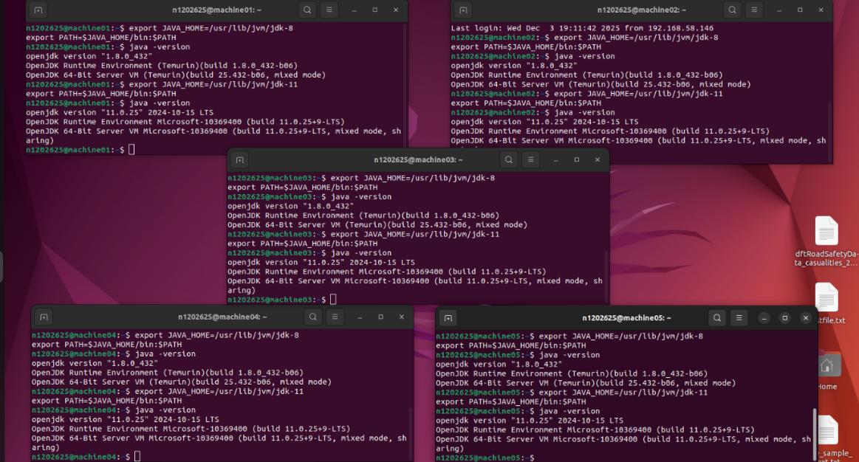
Installing Java 8 - Downloaded OpenJDK 8 from Adoptium ➜ extracted it into the JVM directory ➜ renamed the folder for consistency ➜ enabled access for both root and standard users ➜ verified installation across all nodes. Installing Java 11 (General Use + Spark) - Downloaded the Microsoft Build of OpenJDK 11 ➜ created the JVM directory where required ➜ extracted and renamed the package for clarity ➜ confirmed Java 11 availability for all users. Configuring Java Environment Variables - Added JAVA_HOME and PATH entries to the user profile ➜ reloaded the environment ➜ validated that each node recognised the correct Java version. Configuring Hadoop to Use Java 8 - Updated Hadoop’s environment file to point to the Java 8 installation ➜ applied system-wide Java settings ➜ ensured Hadoop consistently used Java 8 on all nodes.
Figure 1: Java installation verification on all machines

Hadoop installation
Updated system packages and installed Hadoop as a non-root user for security and compatibility ➜ downloaded Hadoop 3.3.6 and extracted it into /usr/local/ to create the main Hadoop directory ➜ created the /usr/local/hadoop symbolic link for easier version management ➜ set ownership and permissions and created required storage and logging directories (/abc for NameNode/DataNode, /usr/local/hadoop/logs) ➜ added key environment variables (HADOOP_HOME, HADOOP_CONF_DIR, PATH) to the user profile ➜ updated hadoop-env.sh to point to the Java 8 installation ➜ configured core-site.xml, hdfs-site.xml, mapred-site.xml, yarn-site.xml, and the workers file to define the filesystem, replication, data paths, YARN settings, and cluster nodes ➜ formatted the NameNode and started all HDFS and YARN services ➜ verified the installation by checking active Hadoop daemons on each machine and confirming live DataNodes and overall cluster health via the web interfaces.
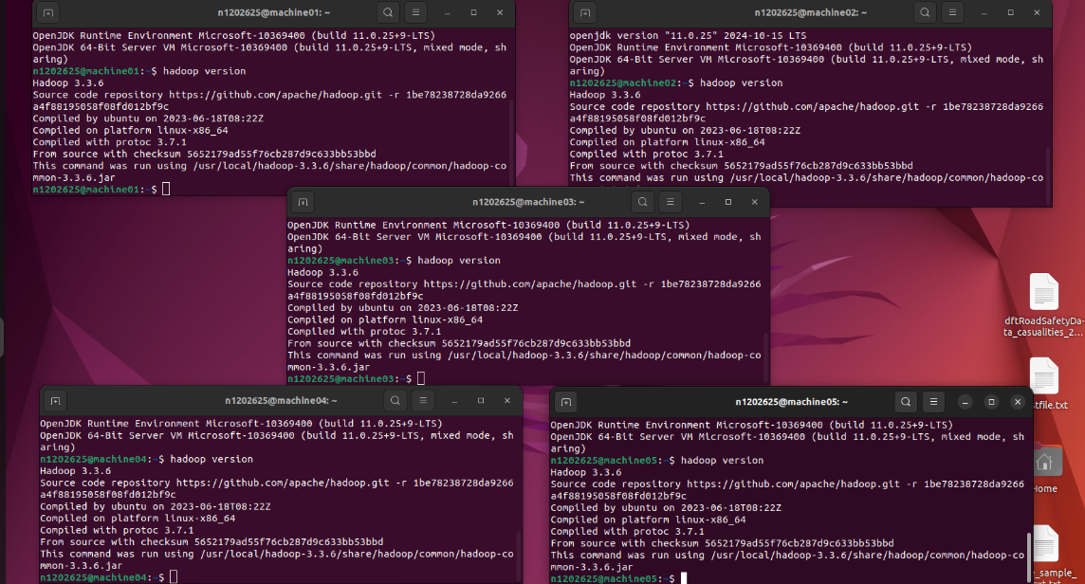

Figure 2: Hadoop installation on all machines

Configuration files
The key Hadoop configuration files located in /usr/local/hadoop/etc/hadoop were edited on all nodes to enable distributed storage, resource management, and multi-node execution.

Core-site.xml -Defines the Hadoop filesystem.
The default filesystem was set to the NameNode hostname using the HDFS UI so all nodes correctly connect to the master.

HDFS-site.xml- Controls how HDFS stores and manages data.
The configuration included setting the replication factor, enabling WebHDFS, and specifying the NameNode and DataNode storage directories (e.g., /abc/name and /abc/data).
This ensured proper block distribution, fault tolerance, and checkpointing.

Mapred-site.xml -Configures MapReduce to run on YARN.
Only the essential property (mapreduce.framework.name = yarn) was required to enable MapReduce execution within the YARN resource manager.

Yarn-site.xml -Enables resource scheduling across the cluster.
Key properties included defining the ResourceManager host, enabling shuffle services for MapReduce, and configuring NodeManager ports and logging.
These settings allow containers to run successfully on all nodes.

Workers file- Lists all nodes (machine01–machine05).
Ensures HDFS DataNode and YARN NodeManager services start correctly across the distributed cluster.

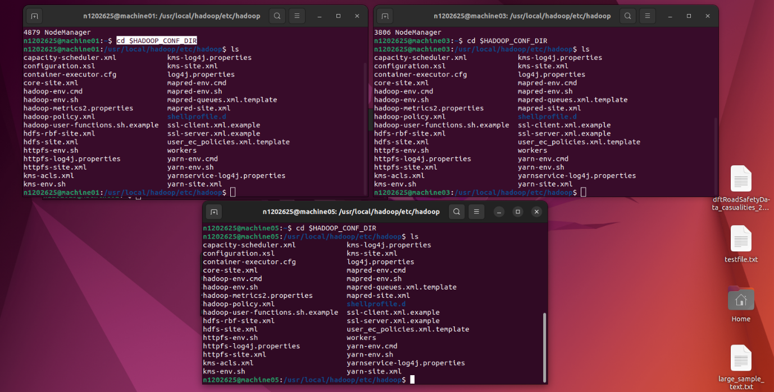
Figure 3: Configuration files under Hadoop Directory on machines 1,3 and 5 for example
Apache Spark Installation
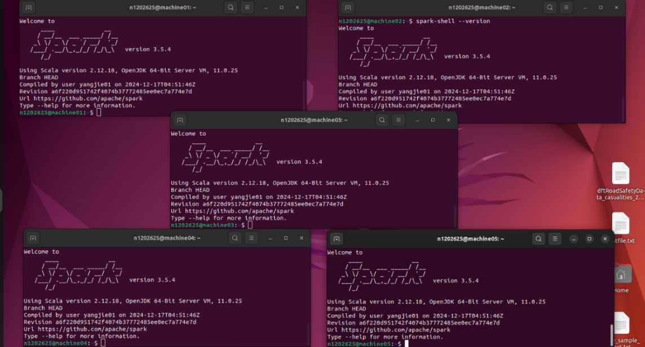
Downloaded Apache Spark 3.5.4 (Hadoop 3.x build) onto the master node ➜ extracted it into /usr/local/ and created the /usr/local/spark symbolic link ➜ set ownership and permissions for the Hadoop user ➜ added SPARK_HOME and Spark paths to .bashrc and reloaded the environment ➜ copied the Spark directory from the master to all worker nodes via SCP ➜ installed Spark on each node by moving it into /usr/local/, recreating the symbolic link, updating ownership, and applying environment variables ➜ configured Spark by editing files in spark/conf, renaming templates, and adding all cluster hostnames to the workers file ➜ updated spark-env.sh with Java and Hadoop paths to enable integration with YARN and HDFS ➜ created local and logging directories (e.g., /var/log/spark, /tmp/spark/local) with correct permissions ➜ verified installation by running a basic Spark command to confirm accessibility, correct configuration, and recognition of distributed mode.
Figure 4: Spark installation in all machines

Firewall Configuration for Multi-Node Hadoop Operation
After installing the required components, I configured the firewall across all five nodes to allow the essential Hadoop and YARN service ports. This step was important because each node must be able to communicate freely with the NameNode, DataNodes, ResourceManager, and JobHistory server.I enabled SSH (port 22) for remote access and allowed all standard Hadoop ports, including the NameNode (9000, 9870), DataNode services (9864, 9866), ResourceManager (8030–8032, 8088), NodeManager ports (8040–8043), and the JobHistory server (19888). Once all rules were added, I enabled UFW and verified the status to confirm that traffic would flow correctly between nodes. This ensured that each machine could participate fully in the distributed cluster without communication failures.

SSH Setup and Passwordless Authentication
Hadoop relies on passwordless SSH for internal automation, such as launching daemons, transferring metadata, and coordinating distributed tasks. I first checked whether SSH was active on each machine, installing it where necessary. I then generated an RSA key pair on machine01 and copied the public key to all nodes, including itself. This allowed machine01 to SSH into machines02–05 without prompting for a password. I repeated this test by running commands such as: ssh machine02. Passwordless SSH worked across all machines, confirming that Hadoop daemons would be able to perform distributed operations automatically.

Preparing the Five-Node Cluster Environment
To build the actual multi-node cluster, I created one fully configured VM and cloned it five times to form machine01- machine05. After cloning, I changed each hostname using hostnamectl and updated network settings so that each machine had a unique IP address. I updated the /etc/hosts file on every node so that each machine could resolve the names machine01–machine05. I tested connectivity by pinging every machine from every other machine. This helped confirm that the network was correctly configured before forming the Hadoop cluster.
At this stage, I also revisited the Hadoop configuration files and assigned the roles:
- machine01: NameNode, ResourceManager, DataNode, NodeManager
- machine02: SecondaryNameNode, DataNode, NodeManager
- machine03–05: DataNode + NodeManager
I updated the workers file on every node so all DataNodes and NodeManagers would start correctly during cluster launch.

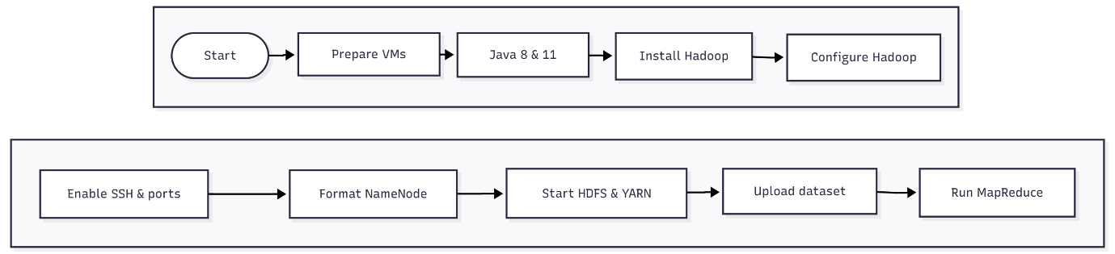

Formatting the NameNode
Before the first run of the distributed cluster, I inspected the /abc directory on machine01 to confirm that it was empty. This directory is used for storing NameNode metadata. I then formatted the NameNode using: hdfs namenode -format. After formatting, I checked the /abc/name directory again to confirm that Hadoop had created the required metadata structure. Formatting prepares HDFS for the first time and should only be done once for a cluster.

Starting the Hadoop Cluster and Verifying Daemons
With networking and configuration complete, I started the entire Hadoop cluster from machine01 using: start-all.sh On machine01, jps showed the NameNode, ResourceManager, SecondaryNameNode, DataNode, and NodeManager running. On the other nodes, I confirmed that the DataNode and NodeManager services were active.
Next, I checked the web interfaces:
- NameNode UI (http://machine01:9870): Verified all DataNodes were “Live”
- ResourceManager UI (http://machine01:8088): Checked that all NodeManagers were registered and healthy
This confirmed that the Hadoop distributed environment was fully operational.
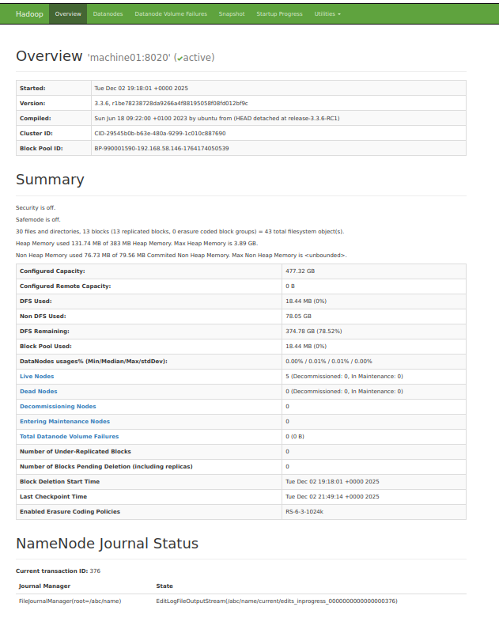
Figure 5: NameNode Web UI (http://machine01:9870/)

HDFS Data Storage Setup and Distribution
Once the cluster was stable, I created a user directory in HDFS and uploaded the Road Safety 2018 dataset. After uploading, I viewed the file via HDFS commands and the NameNode UI. HDFS automatically- Broke the dataset into blocks. Replicated each block across three DataNodes (based on replication factor = 3). Distributed the blocks across machine01–machine05.
Once the Hadoop cluster was fully configured and running, I prepared the storage environment within HDFS by creating a user directory and uploading the Road Safety 2018 dataset into the distributed file system. Unlike a traditional local filesystem, HDFS is designed to store large datasets by breaking them into fixed-size blocks (typically 128 MB by default). When the dataset was uploaded, HDFS automatically divided the file into these blocks and assigned them across the available DataNodes in the cluster.
Because the replication factor was set to three in hdfs-site.xml, each block was stored on three different DataNodes. This ensured fault tolerance: even if one or two nodes failed, the data would remain accessible. The NameNode recorded the metadata for each block—its location, size, and replication status—while the DataNodes stored the physical block files. The distribution occurred across machine02 to machine05, meaning no DataNode stored the entire dataset; instead, each contributed partial storage as part of the larger distributed filesystem. The NameNode UI (port 9870) provided a visual confirmation of this distribution. It showed the list of “Live DataNodes,” the amount of storage each node contributed, the block distribution diagram, and replication health. This allowed me to verify that HDFS was storing and managing the dataset in a balanced and fault-tolerant manner across the entire cluster.

Developing the MapReduce Program
To solve the coursework problem, I created a new directory and wrote three Java files: 1.Mapper: Extracted the casualty severity field from each row and emitted (severity, 1) 2.Reducer: Summed all values for each severity category 3.Driver: Configured job settings, input/output paths, and MapReduce execution via YARN. I exported the required Hadoop classpaths, compiled the Java files, and packaged them into a runnable JAR. This program was specifically designed to compute the total number of accident index occurrences for each casualty severity band.
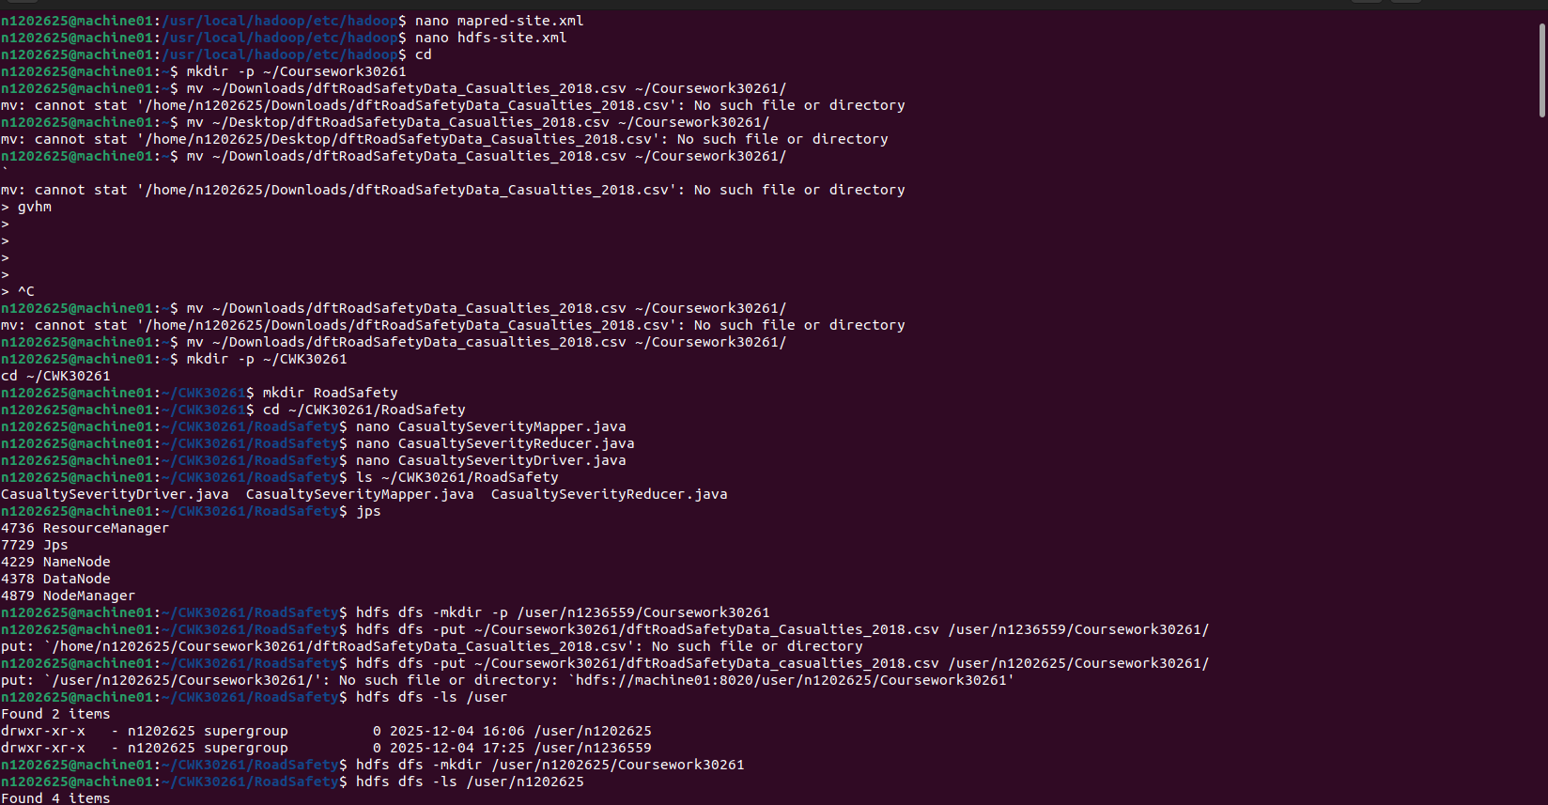
Figure 6: Preparing the Road Safety Dataset and MapReduce Source Files for Execution in Hadoop

Running the MapReduce Job
Before running the job, I started the cluster again to ensure all daemons were active. I then executed the program using: hadoop jar RoadSafetySeverityCount.jar <input_path> <output_path> .The terminal displayed progress updates as map and reduce tasks completed across multiple nodes. YARN handled the scheduling, and the tasks were automatically distributed depending on data locality.
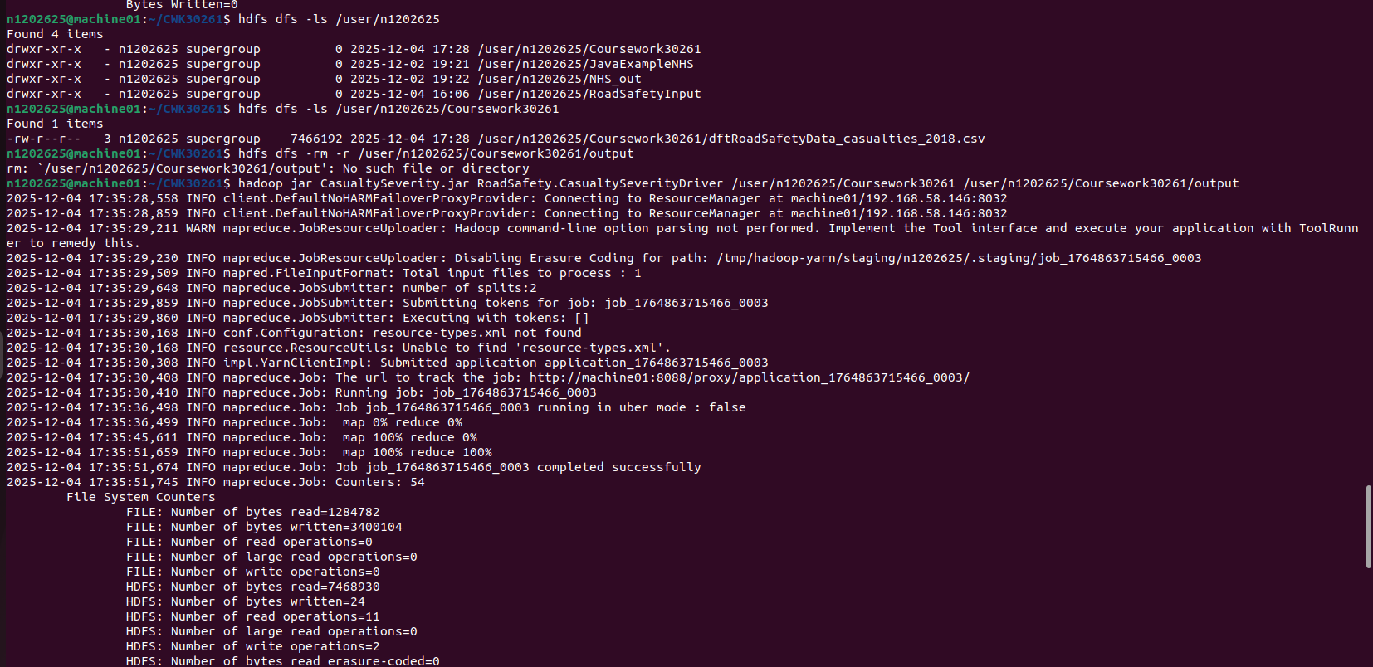
Figure 7 : Terminal Output Showing successful Mapreduce working using jar file

Viewing Results from Terminal and Web Interfaces
Once the job finished, the terminal showed the final counters and the job status as SUCCEEDED. I opened the HDFS output directory and inspected the part-00000 file, which contained the final counts of accident occurrences by casualty severity. Finally, I verified the job in: ResourceManager UI: Displayed the application history, resource usage, and completion status, NameNode UI: Confirmed output file replication and block placement.
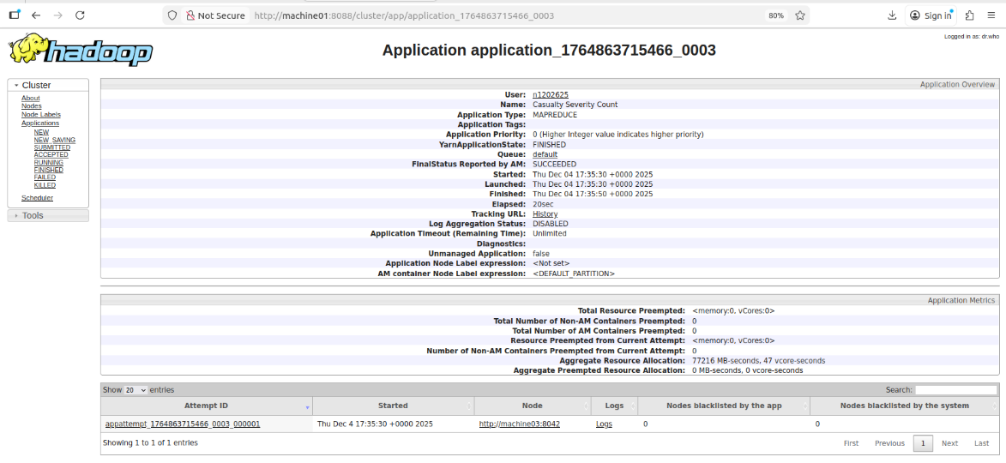
Figure 8: YARN ResourceManager UI Showing Successful Execution of the MapReduce Job

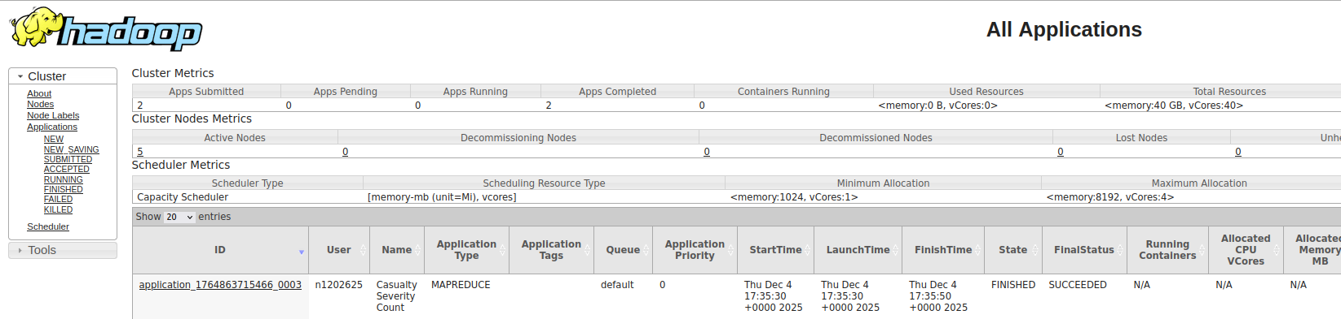
Figure 9 : YARN ResourceManager “All Applications” Page Showing the Completed MapReduce Job

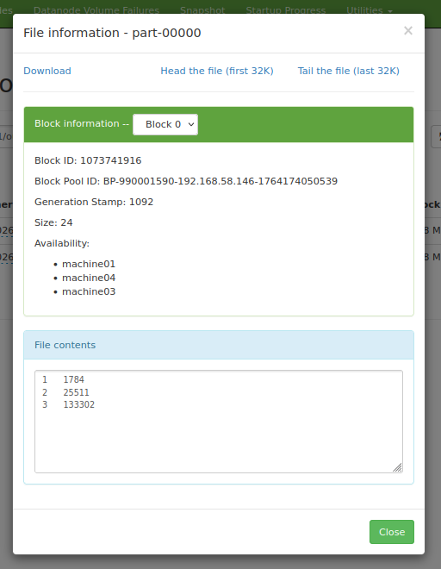
Figure 10: HDFS File Information Displaying Block Distribution and MapReduce Output

Critique, Discussion, and Summary

Evaluation of the Solution: Effectiveness and Efficiency
The five-node Hadoop cluster operated effectively and fulfilled all analytical objectives. HDFS successfully distributed and replicated the 2018 UK Road Safety dataset, while the MapReduce job executed in parallel across the cluster to produce accurate casualty-severity counts. The NameNode and ResourceManager interfaces provided visibility into block placement, task allocation, and resource usage, validating the correctness and efficiency of the system. This confirmed the effectiveness of Hadoop’s storage and computation framework, as described by Shvachko et al. (2010) and Vavilapalli et al. (2013).

What Worked Well
Cluster stability and service configuration: Core Hadoop daemons (NameNode, SecondaryNameNode, ResourceManager, NodeManager) consistently launched across all nodes. Distributed storage performance: HDFS replication and block distribution behaved as expected, offering fault tolerance and balanced data placement. Parallel processing efficiency: Multiple mapper and reducer tasks executed concurrently, demonstrating the power of Hadoop’s pipeline-based parallelism for batch analytics. Monitoring and observability: The web interfaces enabled effective tracking of cluster health and MapReduce job execution.

What Did Not Work Well
Firewall conflicts blocked YARN communication initially, forcing temporary firewall deactivation to complete MapReduce execution. Node-level inconsistencies, such as environment variables and permissions, required manual adjustment during early testing phases. Dataset size limitations prevented deeper evaluation of cluster scalability, resource contention, and long-duration workloads.
While these issues did not prevent project completion, they highlighted the operational complexity of distributed systems.

Insights Gained
The project provided substantial insight into the design and operation of modern distributed data-processing systems. Working directly with Hadoop clarified how HDFS divides data into blocks, replicates them for reliability, and reads data efficiently through locality-aware scheduling (Shvachko et al., 2010). Additional insight was gained into: the functional roles of NameNode, ResourceManager, and DataNodes; the administrative effort required to maintain consistent configuration across nodes; the advantages of executing computation near the data, reducing network overhead; the importance of fault tolerance and replication in enterprise data platforms.

Future Enhancements and Development
Several improvements could strengthen the system and align it with production-ready architectures: Containerisation with Docker or Kubernetes to improve deployment flexibility and mirror contemporary cloud-based big-data platforms (Burns et al., 2016). Re-implementing the workload in Apache Spark, enabling comparison between Spark’s in-memory engine (Zaharia et al., 2016) and MapReduce’s disk-oriented processing. Simulated DataNode failures to observe Hadoop’s automatic re-replication and block recovery mechanisms.Standardising Java runtimes with Eclipse Adoptium Temurin across all nodes to ensure consistent performance and long-term support (Eclipse Adoptium, 2021).

Summary
This coursework delivered a stable and operational Hadoop environment capable of distributed storage and parallel computation across five nodes. The system successfully computed severity-level accident counts from the Road Safety dataset and provided significant practical experience in cluster administration, HDFS configuration, MapReduce execution, and big-data problem-solving. The work demonstrated the strengths of Hadoop’s distributed architecture—replication, scalability, and pipeline-based processing—while also exposing the operational challenges common in large-scale systems. Through implementation, troubleshooting, and optimisation, the project built a strong understanding of modern big-data platforms and created a clear pathway for further enhancement using tools and techniques supported in current industry research (Shvachko et al., 2010; Zaharia et al., 2016; Eclipse Adoptium, 2021).

Appendix
Figure 1. Java Installation on All Nodes
Verification of Java 8 (for Hadoop) and Java 11 (for Spark) installed and recognised across all five machines.
Figure 2. Hadoop Installation Check
Hadoop 3.3.6 version output confirming correct installation on each node in the cluster.
Figure 3. Hadoop Configuration Files
View of $HADOOP_CONF_DIR showing core-site.xml, hdfs-site.xml, mapred-site.xml, yarn-site.xml, and workers file consistently deployed.
Figure 4. Spark Installation Validation
Spark Shell version 3.5.4 running on all nodes, confirming cluster-wide Spark readiness.
Figure 5. NameNode Web UI (HDFS Overview)
HDFS dashboard showing live DataNodes, storage usage, block distribution, and overall cluster health.
Figure 6. Dataset Upload & MapReduce Files
Commands for creating HDFS directories, uploading the dataset, and preparing Java Mapper/Reducer/Driver classes.
Figure 7. MapReduce Job Execution Log
Terminal output showing Map 100%, Reduce 100%, and final job status SUCCEEDED.
Figure 8. YARN Application Overview
Job details for the MapReduce application, including runtime, state, resource usage, and completion status.
Figure 9. YARN Applications Summary
List of completed applications confirming successful MapReduce execution.
Figure 10. HDFS Output File Details (part-00000)
Block information, replication nodes, and file contents showing aggregated casualty-severity values.

Bibliography
Apache Hadoop (2024) Hadoop: HDFS Architecture Guide. Available at: https://hadoop.apache.org/docs/
Apache Spark (2024) Spark Documentation: Cluster Mode Overview. Available at: https://spark.apache.org/docs/latest/
Gov.UK (2019) Reported Road Casualties Great Britain – 2018 Dataset (RAS Data). Available at: https://data.gov.uk/
White, T. (2015) Hadoop: The Definitive Guide. 4th edn. O’Reilly Media.

References
Shvachko, K., Kuang, H., Radia, S. and Chansler, R. (2010) ‘The Hadoop Distributed File System’, 2010 IEEE 26th Symposium on Mass Storage Systems and Technologies (MSST), pp. 1–10.
Vavilapalli, V.K., Murthy, A.C., Douglas, C., Agarwal, S., Konar, M., Evans, R., Graves, T., Lowe, J., Shah, H., Seth, S., Saha, B., Curino, C., O’Malley, O., Reed, J., Baldeschwieler, E. and Black, R. (2013) ‘Apache Hadoop YARN: Yet Another Resource Negotiator’, Proceedings of the 4th Annual Symposium on Cloud Computing, pp. 1–16.
Zaharia, M., Xin, R.S., Wendell, P., Das, T., Armbrust, M., Dave, A., Meng, X., Rosen, J., Venkataraman, S. and Franklin, M.J. (2016) ‘Apache Spark: A Unified Engine for Big Data Processing’, Communications of the ACM, 59(11), pp. 56–65.
Google (2004) ‘Google File System’, SOSP ‘03 Proceedings of the Nineteenth ACM Symposium on Operating Systems Principles, pp. 29–43.
Dean, J. and Ghemawat, S. (2004) ‘MapReduce: Simplified Data Processing on Large Clusters’, OSDI’04: Sixth Symposium on Operating System Design and Implementation, pp. 137–150.
Carbone, P., Katsifodimos, A., Ewen, S., Markl, V., Haridi, S. and Tzoumas, K. (2015) ‘Apache Flink: Stream and Batch Processing in a Single Engine’, IEEE Data Engineering Bulletin, 38(4), pp. 28–38.
Burns, B., Grant, B., Oppenheimer, D., Brewer, E. and Wilkes, J. (2016) ‘Borg, Omega, and Kubernetes’, Communications of the ACM, 59(5), pp. 50–57.
Eclipse Adoptium. (2021) Temurin: OpenJDK Builds. Available at: https://adoptium.net

